# INTERNSHIP REPORT

*Submitted in Partial Fulfilment of the Requirements*

*for the Award of the Degree of*

Bachelor of Computer Applications

By

Deepanshi Kathuria

23215116

Under the Supervision of

Prof. Amrit Kaur

Assistant Professor

School Of Sciences



School of Sciences

July 2025

CERTIFICATE

This is to certify that Deepanshi Kathuria, 23215116, is a bonafide student of CHRIST (Deemed to be University), Delhi NCR, and he has prepared and submitted this report on the Internship Report during July 2025 in partial fulfilment of the requirement for the award of the degree of Bachelor of Computer Applications of this University.

Place: Ghaziabad Date: 20 August 2025

Dr. Bosco Paul Alapatt Associate Dean and Head School of Sciences

# Internship Offer Letter Copy

# w

# Internship Completion Certificate Copy

# 

# DECLARATION

I hereby declare that this report is a genuine description of the “Internship Report”. This report has been prepared under the supervision of Prof. Amrit Kaur and is submitted to CHRIST (Deemed to be University), Delhi NCR 201003 in partial fulfilment for the award of the degree of Bachelor of Computer Applications

Ms. Deepanshi Kathuria

23215116

Prof Amrit Kaur

Assistant Professor

School Of Sciences

Place: Ghaziabad Date: 20 August2025

# ACKNOWLEDGEMENT

# I would like to express my sincere gratitude to Dr. Mudhiwalla Healthcare for giving me the opportunity to undertake my internship and contribute to the development of their official website. This internship has been a valuable experience that allowed me to apply my academic knowledge in a practical environment and gain hands-on exposure to full-stack web development.

# I am especially grateful to Mr. Sanjeet Sahu, the owner of Dr. Mudhiwalla Healthcare, for his continuous guidance, encouragement, and support throughout the course of my internship. His valuable feedback and insights greatly helped me in improving my work and understanding industry expectations.

# I would also like to extend my thanks to my team members, with whom I collaborated during this project. Their cooperation and teamwork made the development process smooth and efficient.

# Finally, I would like to express my gratitude to my college faculty and internship coordinator for their support and mentorship, without which this internship would not have been possible.

**Contents**

Certificate i

Internship Offer Letter Copy ii

Internship Completion Certificate iii

Declaration iv

Acknowledgement v

1. Chapter-1: Introduction 1
   1. Introduction
   2. Objective
   3. About the Company

## Chapter-2: Details of the Internship

* 1. About the Internship
  2. Details of work with screenshots

## Chapter-3: Conclusion

* 1. Key Takeaways and Skills learnt
  2. Key contributions
  3. My testimonials about the Internship
  4. Conclusion

# INTRODUCTION

This report presents a detailed overview of my two-month internship at Dr. Mudhiwalla Healthcare, undertaken from 24th April 2025 to 30th June 2025 as part of my academic curriculum. The primary objective of this internship was to gain hands-on experience in web development by working on the redesign and enhancement of the organization’s official website.

During the internship, I was responsible for designing, developing, and testing a responsive healthcare website that aligned with the clinic’s professional identity and patient-centered approach. My work involved creating two versions of the website: the first focused on building the core structure and essential features, while the second incorporated improved UI/UX design, responsiveness, and database integration for appointment management.

This internship allowed me to apply theoretical knowledge of frontend development, backend integration, and quality assurance in a real-world environment. It also enhanced my skills in requirement analysis, user interface design, testing, and iterative development, preparing me for future professional challenges in the field of web development.

# OBJECTIVE

The objectives of the internship were aligned with both academic requirements and the professional goals of the organization. The major objectives included:

The internship aimed to provide an opportunity to apply theoretical knowledge in real-world scenarios, specifically in web design and development. A major objective was to develop a professional, responsive, and user-friendly website that would represent Dr. Mudhiwalla Healthcare’s identity and enhance its digital presence. Another key objective was to enhance the website’s usability through improved UI/UX design, ensuring that patients and visitors could easily access information and services.

In addition, the internship aimed to provide exposure to backend development by integrating a database to store and manage appointment requests effectively. A further objective was to gain experience in testing and quality assurance, ensuring that the final product was functional, responsive, and reliable across multiple devices and browsers.

Overall, the internship objectives were not only focused on delivering a functional website but also on enabling me to develop practical skills, adaptability, and professional work habits necessary for future career growth.

# ABOUT THE COMPANY

Dr. Mudhiwalla Healthcare, founded in 2024, is a healthcare organization dedicated to preventive health and wellness. The company specializes in providing on-site preventive health screenings for workplaces and communities, focusing on early detection of lifestyle-related health risks. Unlike traditional health check-ups that rely primarily on blood tests, Dr. Mudhiwalla Healthcare adopts a more comprehensive approach by integrating lifestyle assessments with key biomarkers.

The services offered include Heart Attack Risk Profiling, Lifestyle and Stress Screening, Blood Pressure Monitoring, and Obesity Assessment. By analyzing not only clinical reports but also daily habits such as sleep, diet, physical activity, and stress levels, the organization is able to identify hidden risks before they manifest in standard blood results.

With the motto *“Prevention = Early Detection + Timely Action”*, Dr. Mudhiwalla Healthcare aims to empower individuals to make informed lifestyle changes that can significantly reduce the risk of chronic diseases. Operating with a small yet specialized team, the company emphasizes personalized care and preventive strategies rather than reactive treatments.

The organization’s vision is to make preventive health not just a service but a mindset, ensuring healthier lives through awareness, education, and timely interventions.

# ABOUT THE INTERNSHIP

The internship at Dr. Mudhiwalla Healthcare was carried out from 24th April 2025 to 30th June 2025 as part of my academic credit-based program. I was appointed as a Web Development Intern, with the primary responsibility of designing, developing, and enhancing the organization’s official website.

The internship was structured to provide hands-on exposure to the end-to-end process of website development, from requirement gathering to deployment. My tasks involved understanding the healthcare organization’s digital needs, creating an initial functional version of the website (Version 1), and then working on an improved second version (Version 2) with a focus on UI/UX design, responsiveness, and backend integration.

The first phase of the internship concentrated on building the core structure of the website, including pages such as Home, About Us, Services, Doctors, and Contact. The second phase emphasized redesigning the layout, improving user navigation, and integrating a database backend to manage appointment requests. In addition, I performed testing and debugging to ensure cross-browser compatibility and mobile responsiveness.

This internship not only gave me practical experience in frontend and backend web development but also helped me understand the importance of user-centered design in healthcare websites. It provided me with an opportunity to work in a real-world professional environment, apply academic knowledge to practical challenges, and enhance both my technical and problem-solving skills.

# DEATAILS OF THE WORK

**1. Version 1 – Initial Website Development**

* **Description:**  
  The first phase of development focused on building a basic functional website to establish the online presence of Dr. Mudhiwalla Healthcare. This version included only two essential pages:
  1. Landing Page (Homepage): Introduced the healthcare organization with a clean layout, banner section, and navigation links.
  2. Contact Us Page: Featured a simple contact/appointment form allowing users to get in touch with the clinic.
* **Frontend Tech Stack Used:**
  1. HTML5 for content structure.
  2. CSS3 for styling and responsive design.
  3. JavaScript for basic interactivity and form handling.
* **Output:**  
  The Version 1 website established a basic but functional digital presence, allowing patients to access contact details and send inquiries through the form.
* **GitHub Repository:**

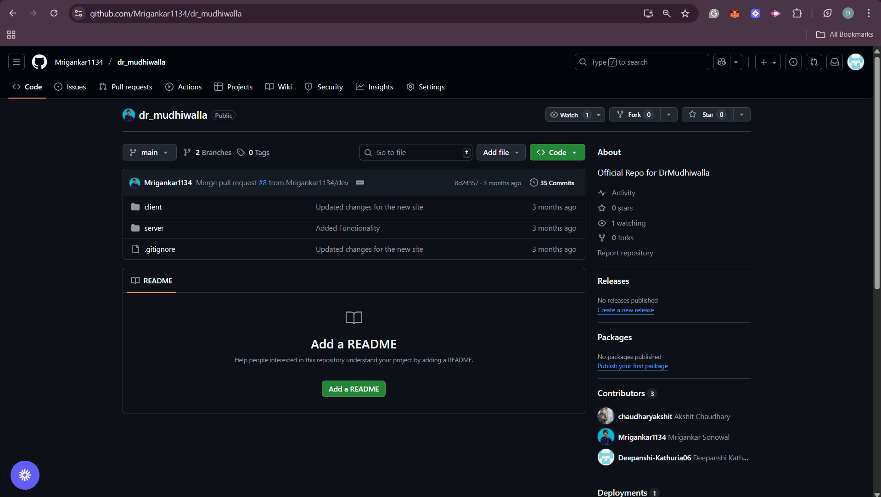

* **Screenshots:**

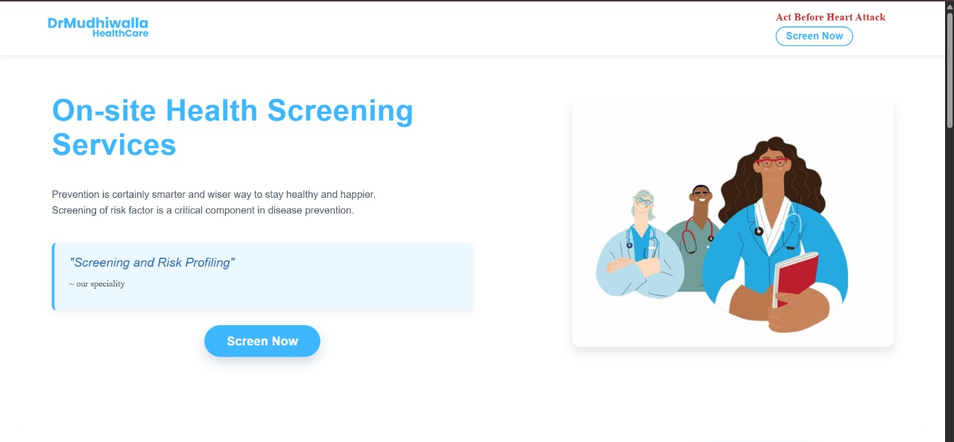

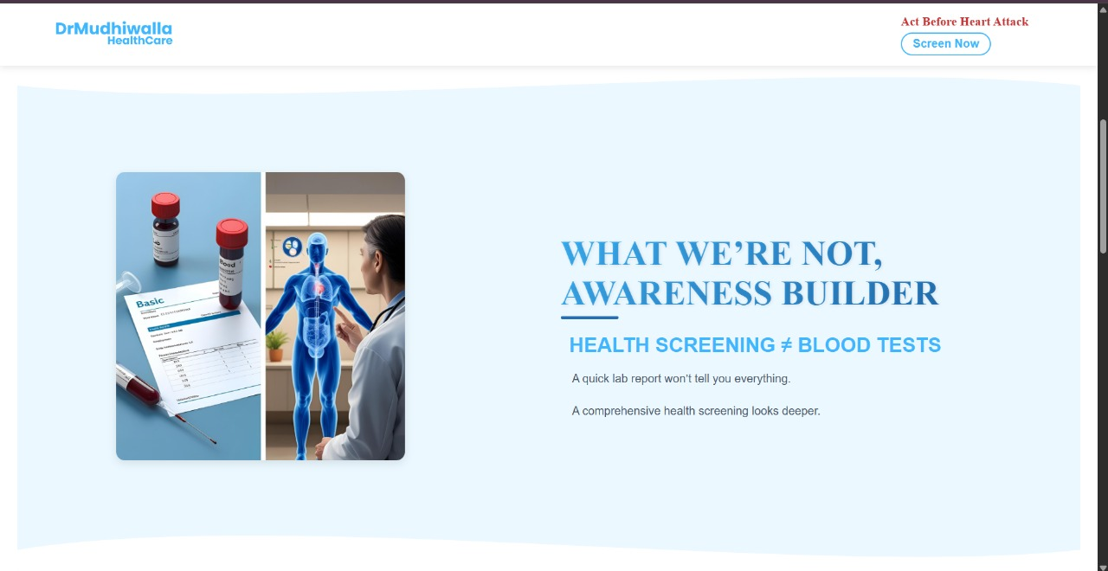

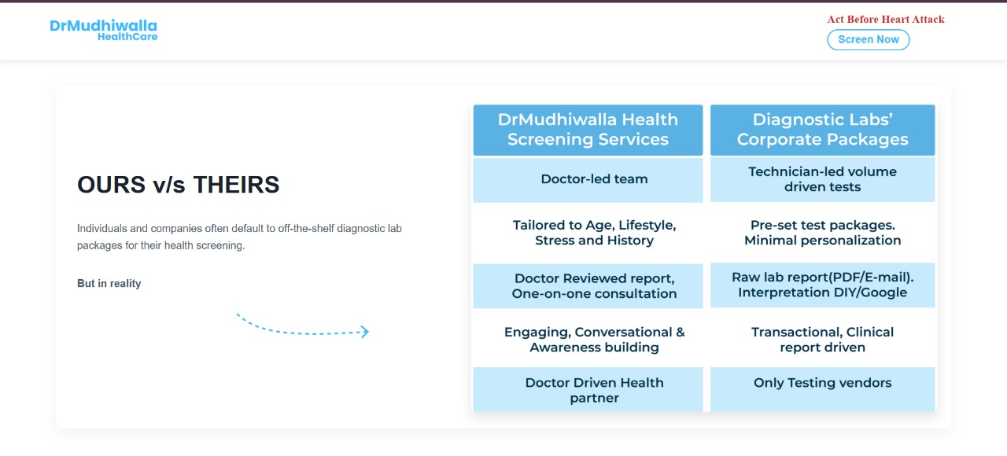

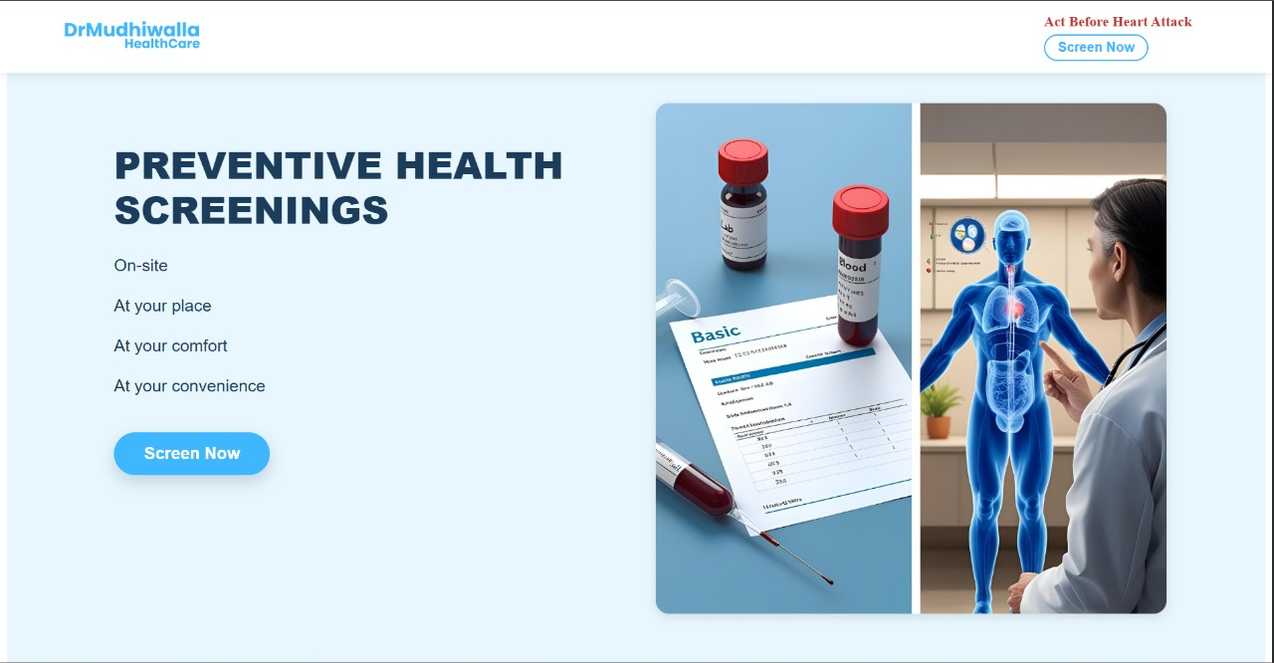

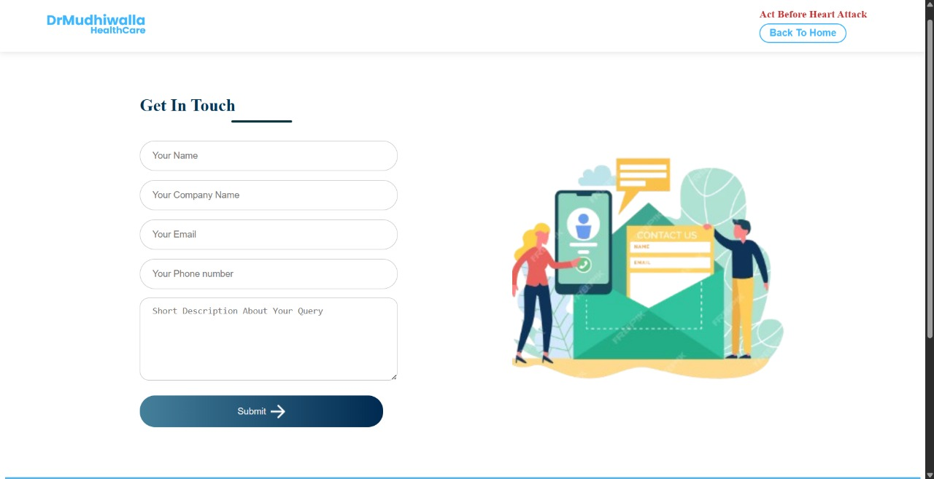

2. Version 2 – Redesigned Website with Backend Integration

* Description:  
  After completing Version 1, feedback was collected to improve the website’s UI/UX design, responsiveness, and functionality. The second version introduced a redesigned layout and added backend connectivity for appointment management.
* Enhancements Done:
* Homepage (Landing Page): Redesigned with a modern layout, improved typography, grid-based sections, and clear call-to-action.
* About & Services Sections: Added as part of the homepage to give users a better understanding of the organization.
* Contact Us Page: Redesigned with styled form fields, validations, and backend connectivity.
* Responsiveness: Improved compatibility across desktop, tablet, and mobile devices.
* Backend Tech Stack Used:
* React.js and Css for the Frontend
* Node.js and Express.js for backend server.
* MongoDB for storing appointment form submissions.
* Mongoose for schema creation and database interaction.
* Output:  
  Version 2 delivered a complete healthcare website with both frontend and backend functionality. Patients could Contact To the organization by filling their Contact Us Form, which were securely stored in the database for the clinic’s use.
* LiveLink:
* Screenshots:

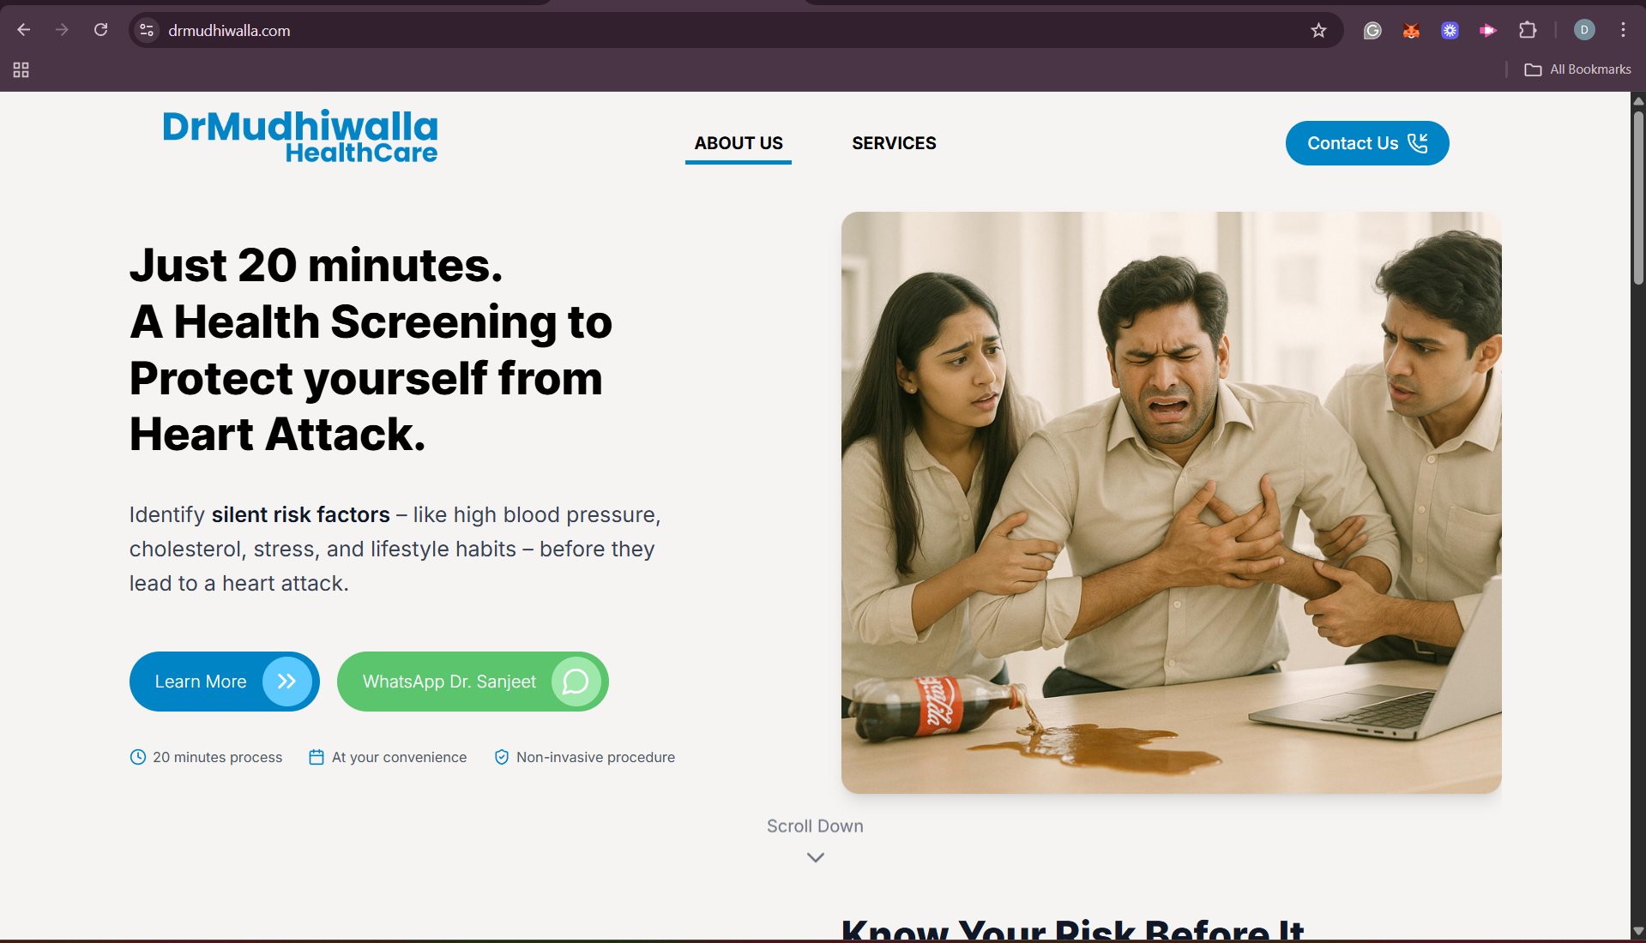

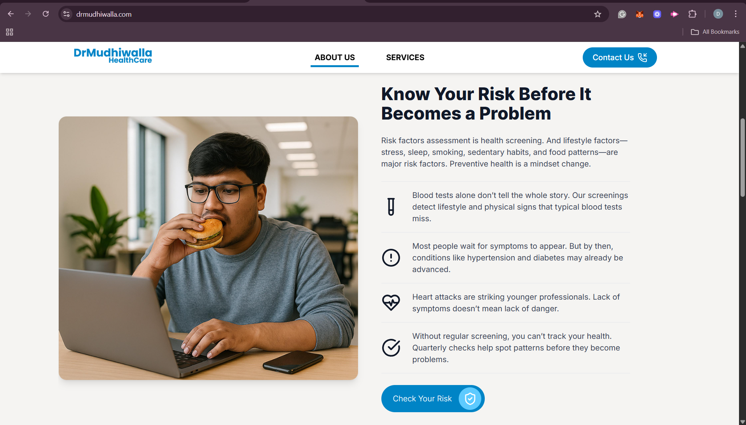

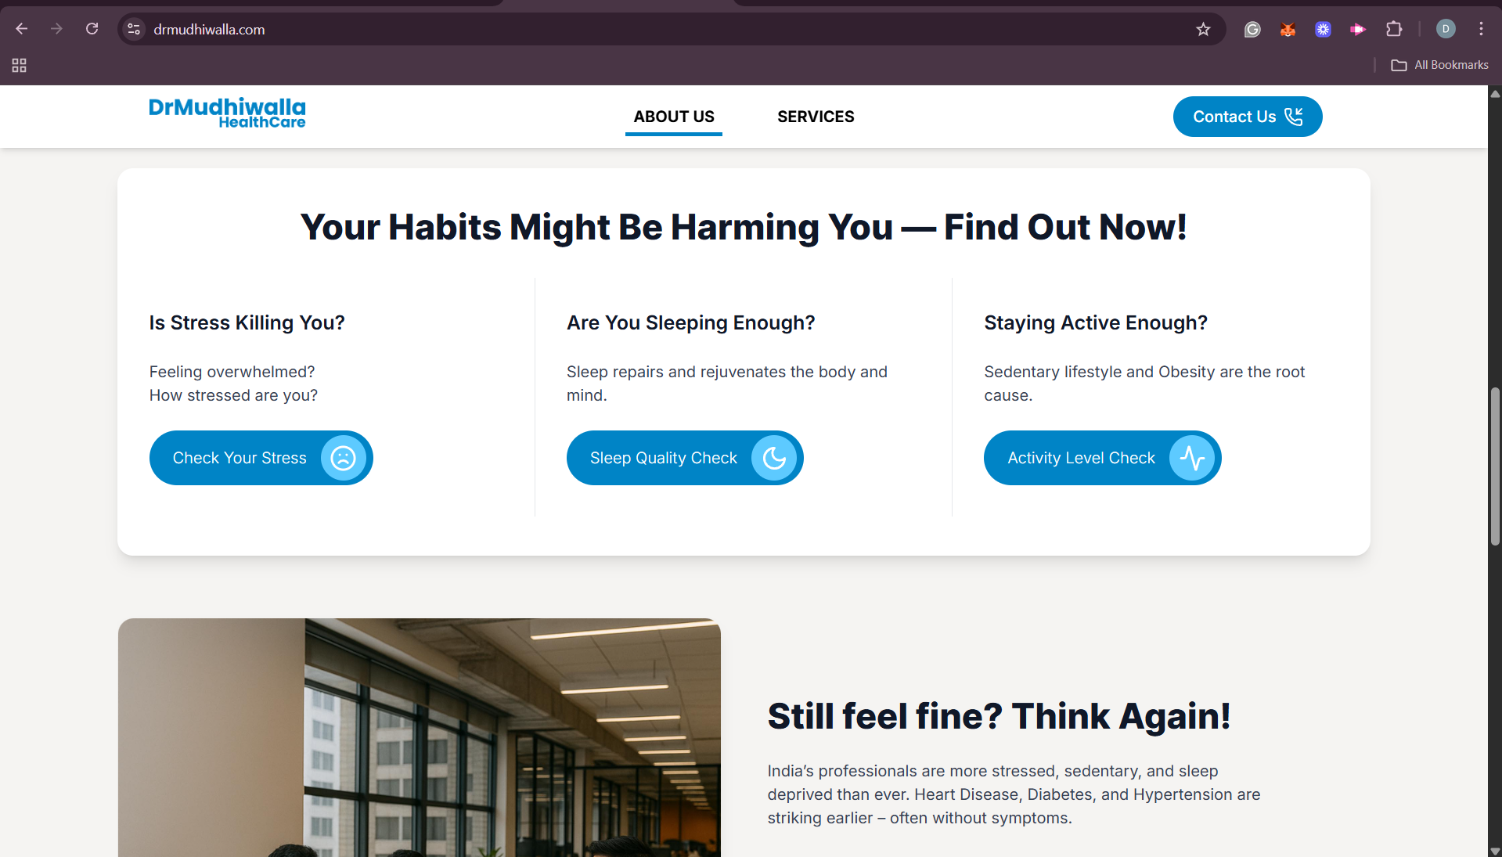

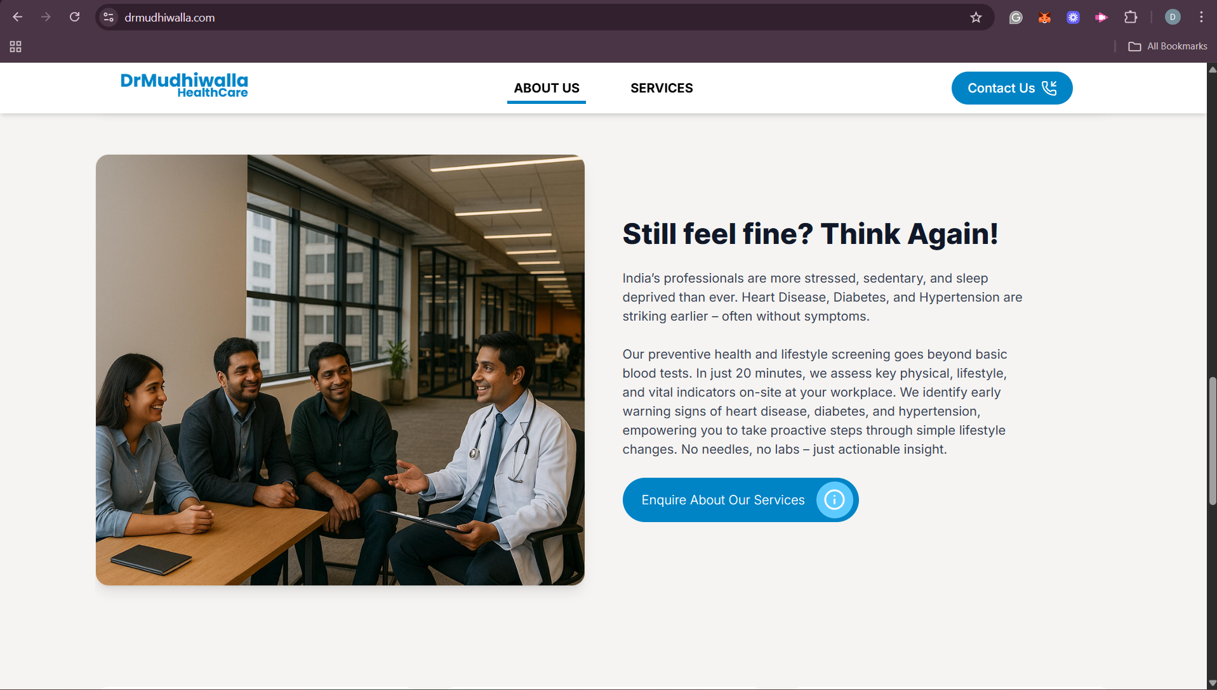

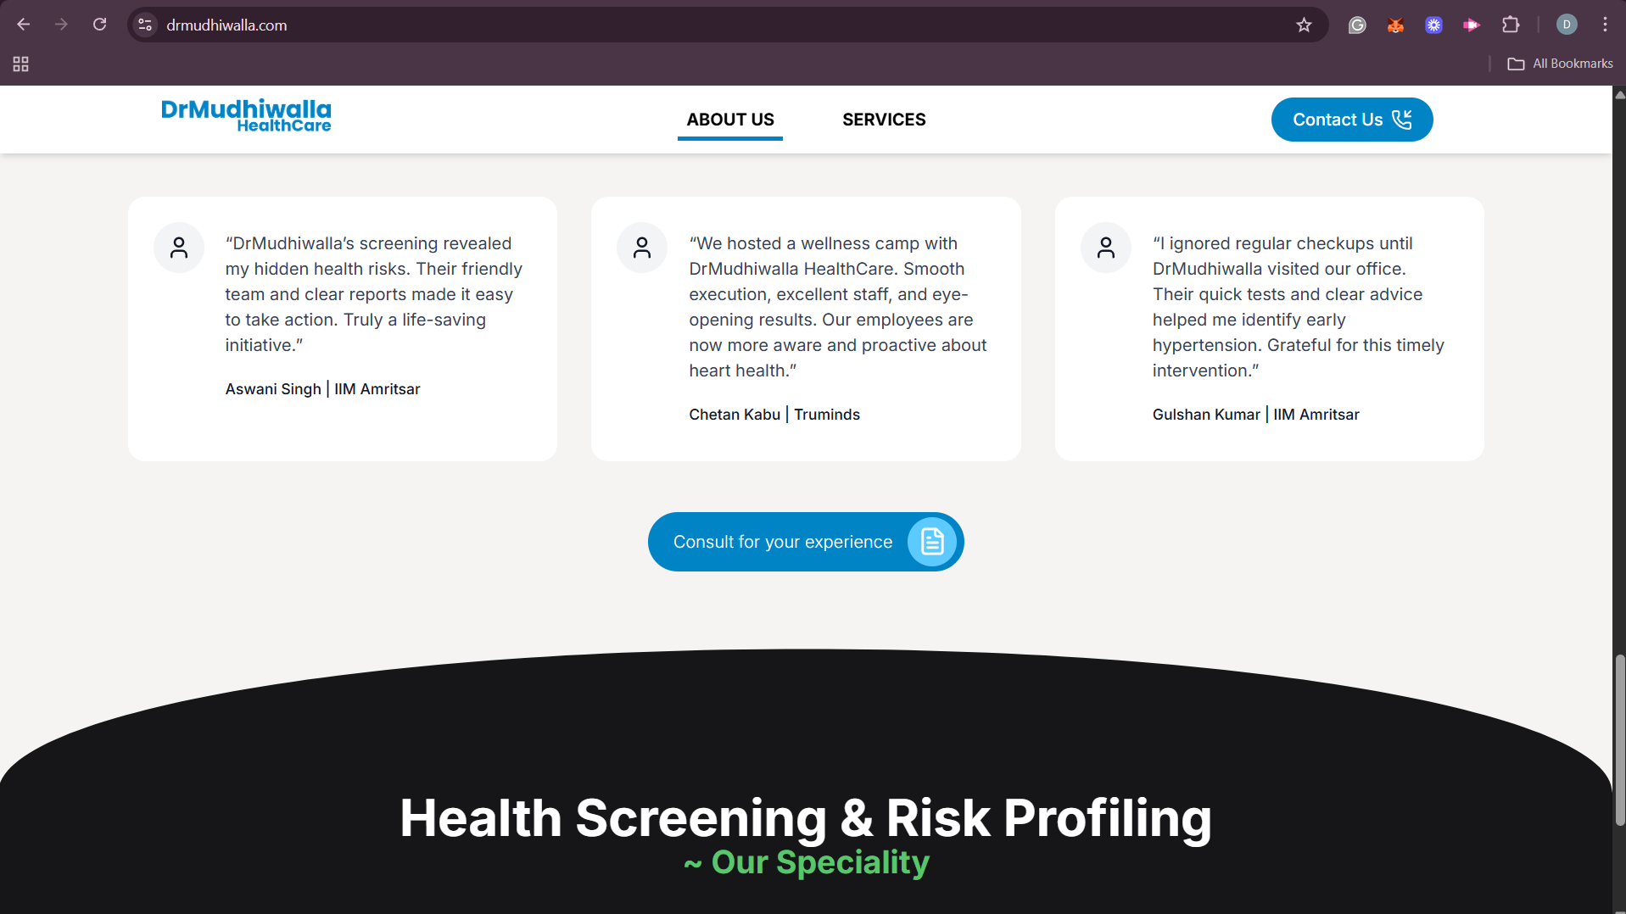

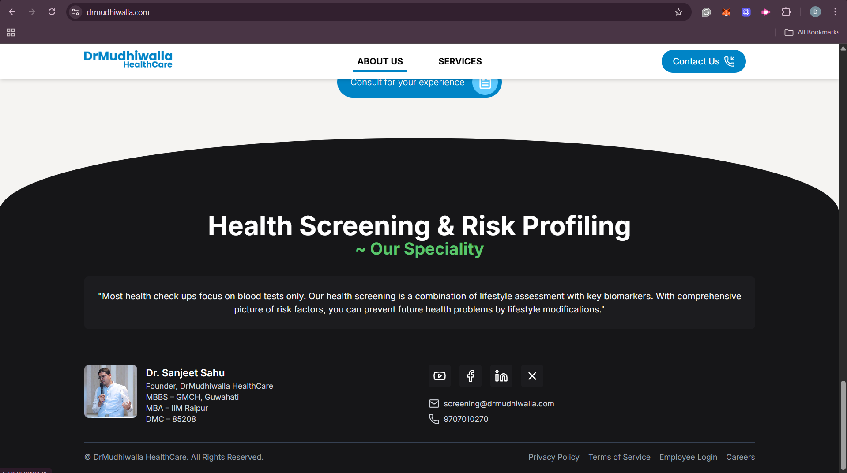

**Chapter 3: Conclusion**

**3.1 Key Takeaways and Skills Learnt**

The internship at Dr. Mudhiwalla Healthcare was a comprehensive learning experience that enhanced both my technical and professional skills. Some of the key takeaways include:

* Gained hands-on experience with the MERN (MongoDB, Express.js, React.js, Node.js) technology stack for full-stack development.
* Applied frontend design principles using React , CSS to build responsive and user-friendly interfaces.
* Implemented backend functionality with Node.js and Express.js, and connected appointment forms to a MongoDB database for secure data management.
* Improved skills in UI/UX design, ensuring that the website was accessible, patient-friendly, and visually consistent.
* Learned testing and debugging techniques for validating functionality, responsiveness, and cross-browser compatibility.
* Strengthened collaboration and communication skills by working in a team with another intern, where we regularly coordinated tasks and reported progress to our mentor.

**3.2 Key Contributions**

My major contributions during the internship included:

* Developing the first version of the healthcare website with a Landing Page and Contact Page.
* Building the second version of the website using the MERN stack, with an improved homepage, redesigned services and contact sections, and database connectivity for appointment management.
* Conducting website testing and debugging, ensuring smooth navigation and consistent performance across devices.
* Actively participating in team collaboration, dividing responsibilities with my teammate to ensure efficiency, and regularly presenting updates to the mentor.
* Documenting progress and feedback, and incorporating suggested changes into the website.

**3.3 My Testimonials about the Internship**

This internship has been a highly rewarding and transformative experience. It gave me the opportunity to apply the MERN stack in a real-world project, allowing me to strengthen both frontend and backend development skills.

Working in a team environment added further value to the internship. Collaborating with another intern not only improved my ability to coordinate and share responsibilities but also taught me the importance of clear communication, teamwork, and regular reporting to mentors.

The support and feedback I received during the internship helped me refine my work and motivated me to think critically about user experience and project scalability. It was not only a technical learning journey but also a chance to grow professionally in terms of accountability, collaboration, and problem-solving.

**3.4 Conclusion**

In conclusion, my internship at Dr. Mudhiwalla Healthcare was an enriching experience that successfully bridged the gap between theory and practice. By working on the healthcare website project, I gained practical knowledge of the MERN stack, web design, database integration, and testing. The project also improved my ability to work effectively in a team environment, where collaboration, regular reporting, and collective problem-solving were crucial for success.

The experience has significantly contributed to my professional growth, equipping me with both technical expertise and workplace skills that will be invaluable for my future career in web development and software engineering.

I would like to express my sincere gratitude to Mr. Sanjeet Sahu, the owner of Dr. Mudhiwalla Healthcare, for providing me with this opportunity and for his constant support and guidance throughout the internship. I am confident that the knowledge and experience gained will serve as a strong foundation for my professional journey ahead.